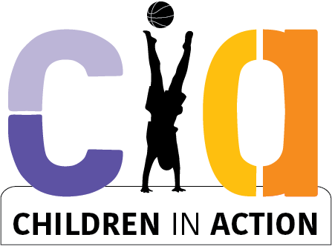
Membership Application
WE NEED TO HEAR WHAT IS IMPORTANT TO YOU!
Send a 2min video telling us why you would like to join us.

The Children In Action (CIA) – Logan Child Reference Group is:

- A group of children from Logan, for grown-ups to talk to who want to hear from children
- Provide feedback to grown-ups about matters that effect Logan children
- Child-led projects - identify ideas & work together to achieve projects and have a channel to ask for help from the Logan community

Nothing About Us Without Us

- The CIA is a place where children can be on the same page together, share ideas, be comfortable and feel safe.
- We are a friendship group and non-toxic
- We are a reference group of children for Logan
- We want to share our voice and be heard. We want to be a group where grown-ups come to us for our advice. A group where Logan kids can have a say in what’s happening
- A group that changes the future
- Group where children can change things and have power

From the GROWN-UPS who are helping the CIA:

Dear Logan Children and Families.

The Children-In-Action Group is coordinated by the Australian Institute of Play.

A lot of us grown-ups are very concerned for children of this modern world, especially your time and space to play.

We are worried that us grown-ups might be changing all the best parts of being a child, like - Being able to connect with friends in real life, being able to play without adults, explore your neighbourhoods, be free, be adventurous, challenge yourselves, have fun, be independent, be confident, feel safe in your community and have great connection to the natural world.

We are looking for more Logan Children to join our group of young change-makers to make sure children have a voice, especially on matters of that are about YOU, especially play. The CIA are looking for more children to join this group. We would like to hear directly from you. Young people (5 to 14yrs or younger).

Do you feel called to join a group of young Logan Leaders are try and make a difference in your community?

Hope to see you soon
Hyahno Moser – CEO
Australian Institute of Play

CIA have spaces for 18 Logan Young Leaders.

To apply you need to live in Logan and be aged 5 to 13 years of age.

Send a 2min video answering the questions below

Your vids will be your application and also used to deliver a message to grown-ups and promote what you want to say.

How does it work?
- CIA meet fortnightly after school
- Every fortnight we switch between an online meeting and a face-to-face meeting
- All meetings incorporate fun as well as talking about projects we are working on
- Face-to-face meetings include play sessions, fun, are catered, and sometimes we meet at parks
- We sometimes invite special guest to our meetings
- We are also invited to speak to grown-ups and provide them feedback on projects or plans they are making for children
- We can also provide support to get to the meeting if transport is a challenge

The young persons selected to be on the CIA will be notified by phone or email.

Here are your questions:

This is your chance to say what is important to you and have your voice heard.

Some questions to get your ideas going:

What does it mean to be a young person in Australia? What are your concerns?

As a child growing up in this modern world, what is important to you in your neighbourhood?

If you could be the ‘Change-Maker’ what would you change?

Are there things you see you are not happy about? Do you need help?

If you could make changes to your neighbourhood, or community, or school, or your environment, what would you suggest?

Children and Play: Tell us about the way today’s children play?

Application Form:

Name: ______________________________________ Age: ________________

Phone: ____________________ Email: _________________________________

What area do you live in? ___________________________________________

- Brainstorm your ideas, what you would like to say in the box below

Filming Tips:

- Use landscape format
- Keep the phone or camera steady
- Check the mic volume is turned up
- Film in a sunny or bright spot
- Have fun!

- Record your video (1-2mins)
It doesn’t need to be fancy – but feel free to be creative - explain what is important to you. What you would you like to say?

- Have your guardian or parent complete media consent form attached (if you have friends in your film, their guardians or parents need to complete and sign a form as well).

- Ask your parent or guardian to email your film and consent form via dropbox (or other file sharing platform) hello@australianinstituteofplay.org (please contact Hyahno on 0403 458 871 if you need support submitting your application).

Applications OPEN NOW.
C.I.A membership will be assessing applications as they come in. So, we will be in touch soon
​APPLICATIONS CLOSE 5PM, Jan 4th, 2023
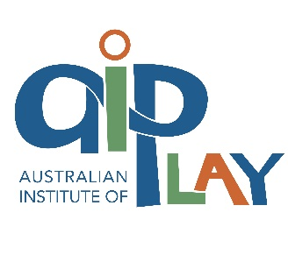
Thanks for being involved.

